Durham Schools Recycling Design Competition

First Name: …………………………. Class name: ………………………….. School Name: ……………………………………………………
Design a bin, divider or box to help people recycle more at one of the places below:
- Kitchen
- Bathroom
- School
- Sports venue
My Design

You can tell us a little bit about your design here. There are some examples below.

………………………………………………………………….……….……………………………………………………
…………………………………………………………………………………………………………………………………
…………………………………………………………………………………………………………………………………

My designs will help people recycle more shampoo bottles.
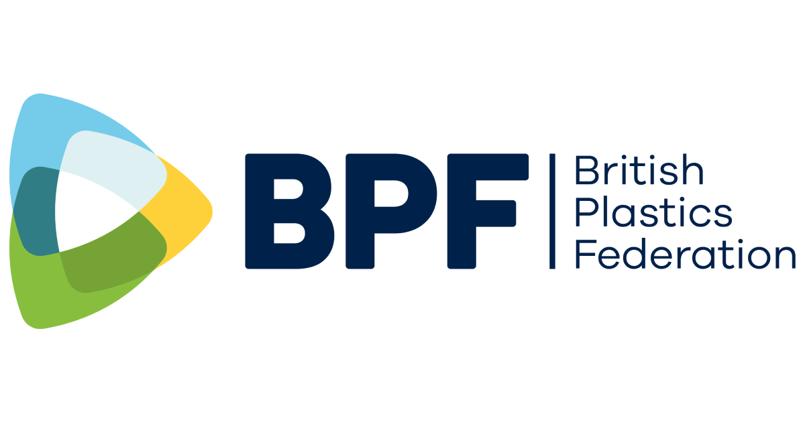
My design will help people recycle more bottles at the football ground.

